**Name: Huynh Lam Student ID: 13264763 Date: 05/09/2021 Activity No.: Cmp1/03**

**Due Date:** Three days after the lab.

# Setup

You need to download this week’s samples onto a Linux Box.

# Q1) Hex Viewer – cmd line

We can use xxd -l 256 to see the file signatures.

|  |  |  |
| --- | --- | --- |
| **File** | **Hex Signature** | **exe PE Jump**  **address** |
| Trade_secrets.txt | Ascii text |  |
| logo.gif | GIF89a at 00 |  |
| MS Office Meta Data.jpg | (JFIF) FFD8 FF |  |
| IMAG1672a.jpg | (JFIF) FFD8 FF |  |
| Cygwin1.dll | (MZ) 4d5a |  |
| Strings.exe | (MZ) 4d5a | D8 |
| Sample.docs | (PK) 504B 0304 |  |
| Sample.pdf | (%PDF) 2550 4446 |  |
| Flowers.txt | (MZ) 4d5a | 80 |
| Cars.txt | (MZ) 4d5a | D8 |

Note your response in the table

Can you determine the imposters file type?

* Flowers.txt should be exe
* cars.txt should be exe

Exe files have a PE jump between 80 and FF see slides. Add to the table.(exe only)

Why does the address of the PE marker vary?

* These files are referred to as Portable Executable PE. The name Portable Executable refers to the fact that the format is not architecture specific which means the address of PE being in a different spot is normal

# 

# Q2) Magic Files

We use Linux command file on your downloaded files.

Open a Linux shell window and cd to your Forensics folder.

Use the command file to check the file extensions.

file /mnt/c/Forensics_yourname * | cut -c 1-120

|  |  |
| --- | --- |
| **File** | **Magic Signature** |
| Trade_secrets.txt | iso-8859 (simple) text, CRLF |
| logo.gif | version 89a, 220 x 50 pixels |
| MS Office Meta Data.jpg | JPEG image data, JFIF standard 1.01, resolution (DPI) |
| IMAG1672a.jpg | JPEG image data, JFIF standard 1.01, resolution (DPI) |
| cygwin1.dll | PE32 executable (DLL) (console) Intel 80386, for MS Windows |
| strings.exe | PE32 executable (console) Intel 80386, for MS Windows |
| Sample.docs | Microsoft Word 2007+ |
| Sample.pdf | PDF document, version 1.5 |
| Flowers.txt | PE32 executable (DLL) (console) Intel 80386, for MS Windows |
| cars.txt | PE32 executable (console) Intel 80386, for MS Windows |

Add the responses in the table

Are any files imposters as seen by file?

Imposters: Cars and flowers text files are exe files

Run file again on ls2.exe without using cut.

ls2.exe is a compressed form of ls.exe using UPX packing to avoid detection in an IDS.

You can also use xxd on ls2.exe and grep for UPX. Take a screenshot of this cmd and the result.

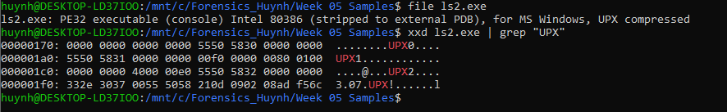

What is UPX packing?

* UPX (Ultimate Packer for Executables) is an open-source executable packer supporting a number of file formats from different operating systems.
* By packing malware binary files, the data stored within the file becomes unreadable and thus will need to be unpacked in order to become readable again. These require the malware to be unpacked manually

# Q3) Editing a File Header

Confirm you have the Image File C08InChp.dd in your Forensics folder.

Run ProDiscover.

Add Image File C08InChp.dd.

Search for FIF case sensitive

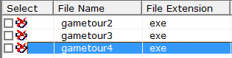Click Show File. You should see a deleted file called gametour4.exe.

Right click, select copy file, save as Recover1.jpg in your Forensics folder. Exit ProDiscover.

Run HxD.exe in your Forensics folder. (Download and Install HXD as required,)

Open Recover1.jpg

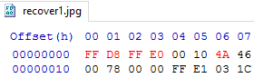Change the header from 7A 7A 7A 7A to FF D8 FF E0 (see lecture slides).

Change the 7A at address 06 to 4A.

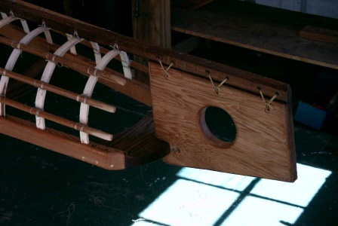

Does the image support the allegation?

* If the image is part of the bike next model that has not been released by the company, then the image does support the allegation otherwise there would be more evidence needed

# Q4) File Metadata

Confirm you have downloaded the sample files as in Q1.

Q4 A) docx files

Use the Windows 10 File Explorer.

Right click **Sample.docx** and select properties. Select the details tab.

Note the metadata.

What is the Document Title? Forensic Sample

What is the Document Subject? Forensic

What are the Document Tags? Forensics, Metadata

Who is the Author? G G Lee

When was it last printed? 9/29/2013 4:36 PM

Q4 B) pdf files

Open Sample.pdf with a pdf reader such as pdf-XChange or Chrome. Select the File Tab.

<https://www.tracker-software.com/product/pdf-xchange-editor>

Check the Document Properties.

Note here data of forensic interest:

List the tag:value pairs of forensic interest and explain what they mean.

The Title Forensic Sample (Title of the PDF Document)

The Keywords Forensics, Metadata (Keywords to specify what the topic is)

The Author G G Lee (The owner or author of this document)

The program that generated the pdf. Microsoft Word 2021 (This is the original program before it was a PDF)

The date last modified 29/09/2013, 16:36:31 (file was last 'Saved' by an application (whether or not its contents were actually modified/changed)

(This is usually the same as the file modify date.)

The PDF Version 1.5 (Version of the PDF)

Q4 C) Changing file dates

You need the Linux Box you used in Q1 again.

Open your Terminal shell and cd to the folder containing your sample files.

Let us now **stat** Sample.pdf

**stat Sample.pdf**

Note here the file modify date Modify: 2021-08-25 17:38:01.418284500 +1000

Does it match the Meta data date above? No

Now **touch** the modify date.

**touch –m Sample.pdf**

Use stat to check the modify date is now today Modify: 2021-08-25 18:43:11.042835400 +1000

Does the File modify date still match the pdf metadata date as seen by pdfinfo?

__ The file modify date has changed in Linux WSL, but the pdf properties have stayed the same

## D) Exif files

Use the Windows 10 File Explorer to select IMAG1762a.jpg.

Look at the image file properties.

Explain the several dates.

* Date taken is when the photo was taken
* Date created should be the date that a particular physical instance of a file was written to disk
* Date modified should only ever be the date that the file was last 'Saved' by an application (whether or not its contents were actually modified/changed)

What is the camera? HTC Sensation Z710a

Where was the photo taken? Balmoral, Mosman NSW 2088

Explain how you decoded the GPS coordinates.

* Using this link I was able to find the location
* [https://support.google.com/maps/answer/18539?hl=en&co=GENIE.Platform%3DDesktop]
* GPS Latitude: 33°49' 37.86 S
* GPS Longitude: 151°15' 7.42 E

## E) Other Metadata Samples

Find more files with interesting metadata. (Email? Photos?)

Describe the file and it's metadata of forensic interest.

Chosen to do Microsoft Teams

* Microsoft teams exe file is an automatic update file when the shortcut is ran
* This has the product detail such as name and version
* Company details which are Microsoft Corporation
* Date modified would be the date that it was installed

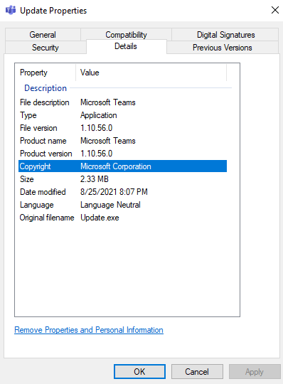

_______________________

# Q5) Hashing.

Run Ubuntu on Windows 10. Then cd to /mnt/c/Forensics_yourname.

Create a text file called test with contents "I will pay you \$1000" using echo. Note the back slash. Check with cat test.

Create a second file called test1 with contents "I will pay you \$9000" using echo.

Compare the two file lengths with ls -al

Hash both files with md5 and then sha 256.

Compare the two md5 hash lengths and compare the two sha 256 hash lengths.

* md5:
  + Test: bf46cb4b5c674364cfee4646e3242ed1
  + Test1: 986a3bbc1f093bebc6099ea1455791ca
* SHA256:
  + Test: 2f4e2783e383159132ba9a70a953cd10e256c366512c07b268cb9f08116a25b6
  + Test2: 3f80ccf5925354d48d1bb98952608ebcbe286326d89e2522cc1b0238b3af2738

Compare the hashes of the two files. The hash length for both hashes is respectively the same number of characters. However, MD5 results in an output of 128 bits whereas SHA256 results output of 256 bits.

Take a screen shot showing the two file lengths, the two MD5 hashes and the two SHA 256 hashes.

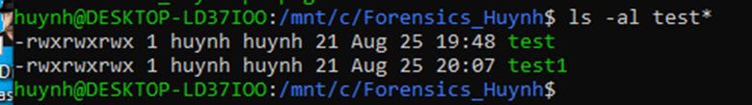

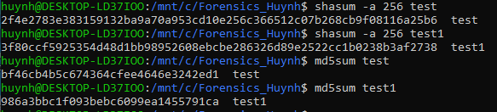

Comment on the results as follows:.

* What is the change in file length as seen by ls? There is no change in the file length
* How does MD5 output differ from SHA 256? MD5 results in an output of 128 bits whereas SHA256 results output of 256 bits.
* What is the change in the hash lengths of the two files?
  + SHA256 has 64 characters and is 256 bits
  + MD5 has and is 32 characters 128 bits
* What is the change in the hash values of the two files? Both hashes are alphanumeric characters and have their own respective order which are different to each other
* How good is hashing in protecting a file integrity? Hash values are also useful for verifying the integrity of data. Hashing is useful in verifying the actual integrity of a file to prevent anybody from changing the content of a file or corrupting it and passing it off as the original file.
* How can you fool hashing? There is a chance that 2 files can output the same hash number. This is very unlikely, but it is called a hash collision. Since a hash function gets us a small number for a big key, there is the possibility that two keys result in the same value.

Explain the 512 and 224 options for SHA 2. These are different hash functions. SHA-512 novel hash functions computed with 64-bit words. SHA-224 are truncated versions of SHA-512. SHA-512/224 is a method for generating initial values for truncated versions of SHA-512. The 2 functions produce the digest of a message, respectively 512 and 224 bits long

What was SHA 3 originally called? Keccak

Is SHA 3 better than SHA 2? In terms of collision potential SHA-3 is better and stronger than SHA-2 since SHA-3 uses more bits

Try this commandopenssl speed sha256 sha512 What does it show you?

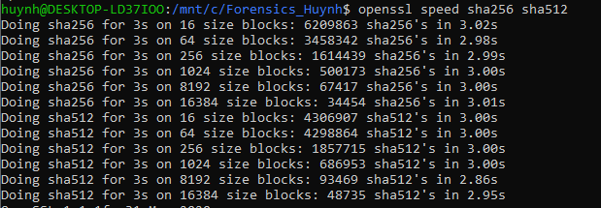



The OpenSSL Speed command shows us the speed output for these algorithms. As you can see we move up the input block size the speed for SHA-3 processes much faster than SHA-2. With a smaller string sizes SHA-2 still performs faster.